**STUDENT MANAGEMENT SYSTEM**

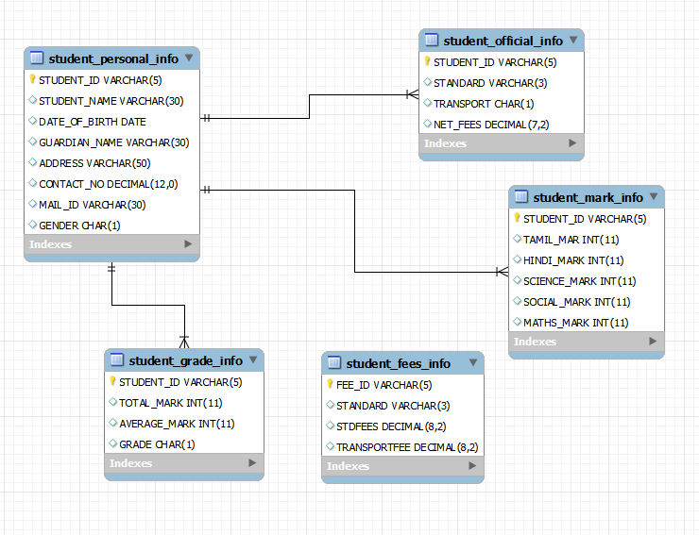

**DDL COMMENTS**

CREATE TABLE STUDENT_PERSONAL_INFO

(

STUDENT_ID VARCHAR(5),

STUDENT_NAME VARCHAR(30),

DATE_OF_BIRTH DATE,

GUARDIAN_NAME VARCHAR(30),

ADDRESS VARCHAR(50),

CONTACT_NO decimal(12,0),

MAIL_ID VARCHAR(30),

GENDER CHAR(1),

CONSTRAINT STUD_PERS_INFO_PK PRIMARY KEY(STUDENT_ID)

);

CREATE TABLE STUDENT_OFFICIAL_INFO

(

STUDENT_ID VARCHAR(5),

STANDARD VARCHAR(3),

TRANSPORT CHAR(1),

NET_FEES decimal(7,2),

CONSTRAINT STUD_OFF_INFO_PK PRIMARY KEY(STUDENT_ID),

CONSTRAINT STUD_OFF_INFO_FK FOREIGN KEY(STUDENT_ID) REFERENCES STUDENT_PERSONAL_INFO(STUDENT_ID)

);

CREATE TABLE STUDENT_FEES_INFO

(

FEE_ID VARCHAR(5),

STANDARD varchar(3),

STDFEES decimal(8,2),

TRANSPORTFEE decimal(8,2),

CONSTRAINT STUD_FEE_INFO_PK PRIMARY KEY(FEE_ID)

);

CREATE TABLE STUDENT_MARK_INFO

(

STUDENT_ID varchar(5),

TAMIL_MAR INTEGER CHECK(TAMIL_MARK BETWEEN 0 AND 100),

HINDI_MARK INTEGER CHECK(HINDI_MARK BETWEEN 0 AND 100),

SCIENCE_MARK INTEGER CHECK(SCIENCE_MARK BETWEEN 0 AND 100),

SOCIAL_MARK INTEGER CHECK(SOCIAL_MARK BETWEEN 0 AND 100),

MATHS_MARK INTEGER CHECK(MATHS_MARK BETWEEN 0 AND 100),

CONSTRAINT STUD_MARK_INFO_PK PRIMARY KEY(STUDENT_ID)

);

CREATE TABLE STUDENT_GRADE_INFO

(

STUDENT_ID varchar(5),

TOTAL_MARK integer CHECK(TOTAL_MARK BETWEEN 0 AND 500),

AVERAGE_MARK integer CHECK(AVERAGE_MARK BETWEEN 0 AND 100),

GRADE CHAR(1),

CONSTRAINT STUD_GRADE_INFO_PK PRIMARY KEY(STUDENT_ID)

);

**DML COMMANDS**

insert into student_personal_info values('s01','sujit koley','1999-06-10','swapan koley','hooghly',9051296438,'sujit9@gmail.com','M');

insert into student_personal_info values('s02','samar pal','1998-05-10','somnath pal','nodiya',9051286438,'samar9@gmail.com','M');

insert into student_personal_info values('s03','tapasi das','1998-04-10','tapan roy','kolkata',9058296438,'tapasi9@gmail.com','F');

insert into student_personal_info values('s04','soumik ghosh','1999-02-10','sumanta ghosh','hooghly',9051236438,'soumik9@gmail.com','M');

insert into student_personal_info values('s05','krish mondal','1999-07-10','swapan koley','hooghly',9051296438,'sujit9@gmail.com','M');

insert into student_personal_info values('s06','chiru das','1998-06-10','somen das','midnapore',9056296438,'chiru9@gmail.com','M');

insert into student_official_info values('s01','I','Y',3000);

insert into student_official_info values('s02','II','N',3000);

insert into student_official_info values('s03','III','Y',5000);

insert into student_official_info values('s04','I','N',2000);

insert into student_official_info values('s05','II','Y',4000);

insert into student_official_info values('s06','I','Y',3000);

insert into student_fees_info values('f01','I',2000,1000);

insert into student_fees_info values('f02','II',3000,1000);

insert into student_fees_info values('f03','III',4000,1000);

insert into STUDENT_MARK_INFO values('s01',80,90,80,70,89);

insert into STUDENT_MARK_INFO values('s02',84,90,89,80,80);

insert into STUDENT_MARK_INFO values('s03',80,90,80,90,80);

insert into STUDENT_MARK_INFO values('s04',70,90,90,80,85);

insert into STUDENT_MARK_INFO values('s05',98,90,90,90,89);

insert into STUDENT_MARK_INFO values('s06',39,40,30,45,30);

insert into student_grade_info values('s01',409,81,'E');

insert into student_grade_info values('s02',423,84,'E');

insert into student_grade_info values('s03',420,84,'E');

insert into student_grade_info values('s04',415,83,'E');

insert into student_grade_info values('s05',457,91,'O');

insert into student_grade_info values('s06',184,36,'F');